Submitted By
Waleed Luqman
Computer Science
Winter 2026
January 24,2026

Internship

Design Proposal

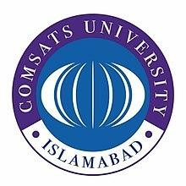

COMSATS University Islamabad, Abbottabad Campus
19

1. Organization Overview & Role
Elite Tech Solutions (Pvt.) Limited is a software development company specializing in modern web solutions. I will work as a MERN Stack Intern, assisting in front-end and back-end development tasks under supervision.
2.Scope of Work
The internship focuses on hands-on MERN Stack development, including building, testing, and improving full-stack web applications using modern development practices.
2.1. Key Activities (check all that apply):
☐ Coding ☐ Testing ☐ Documentation ☐ Data Analysis
☐ Research ☐ Technical Support ☐ Dashboard/Report Creation
☐ Other (please Specify)

2.2. Tools/Technologies to be used:
MongoDB, Express.js, React.js, Node.js, JavaScript, HTML, CSS, REST APIs, Git/GitHub, Visual Studio Code.

2.3. Expected Deliverables:

Basic full-stack web modules, functional APIs, frontend components, backend integration, documented source code, and a final MERN Stack project.

Student Signature: 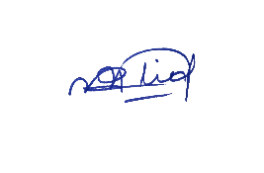 Date: ______________

Internship Supervisor (if any): ___________________ Date: ______________

20

